Data Analysis 101

Summarizing and visualizing data using Pivot tools in MS Excel

# Sourcing data

1. Dataset on city-wide victims of gun violence, available through Open Data Philly: [Shooting Victims Dataset](https://opendataphilly.org/dataset/shooting-victims)
2. Download the dataset as a CSV file and save on your computer
3. Review dataset metadata to learn more about the dataset: [Shooting Victims Dataset Metadata](https://metadata.phila.gov/#home/datasetdetails/5719551277d6389f3005a610/representationdetails/5719551277d6389f3005a614/)

# Summarizing data

1. Open data in MS Excel

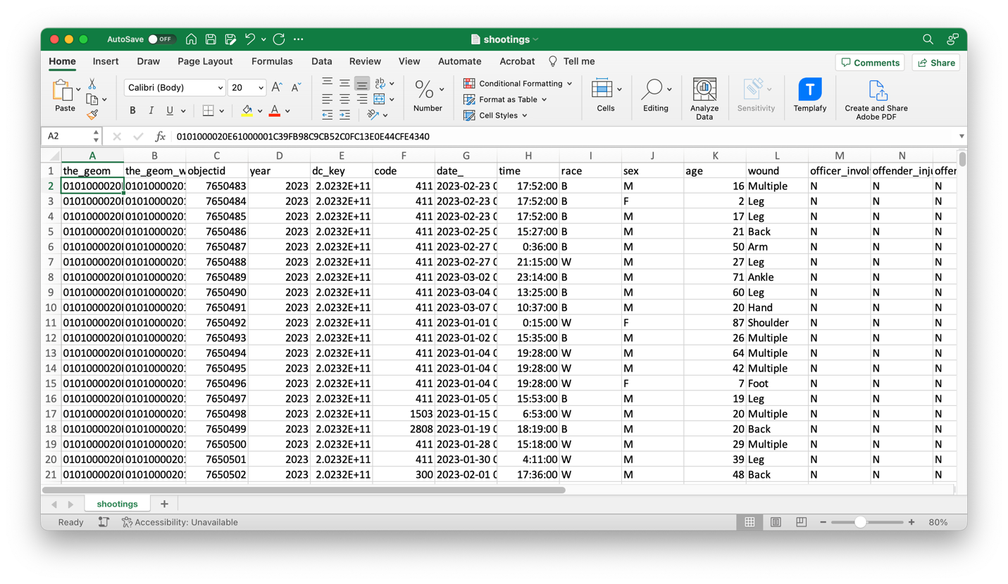

1. Click somewhere in the data and create pivot table  
   Steps: Insert> PivotTable

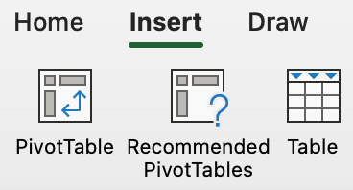

1. Choose where to place the PivotTable, in the same worksheet as the data, or in a new worksheet

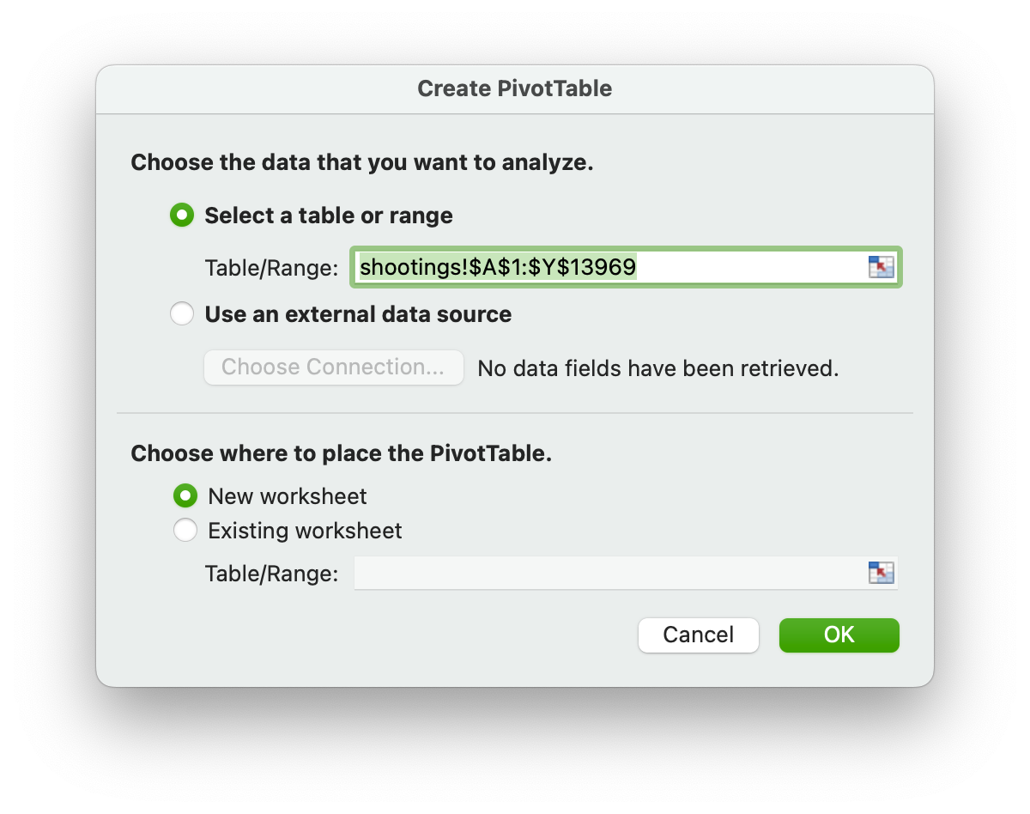

1. The newly created PivotTable will show up in a new worksheet on the left hand side, and a panel with different customization options will show up on the right hand side

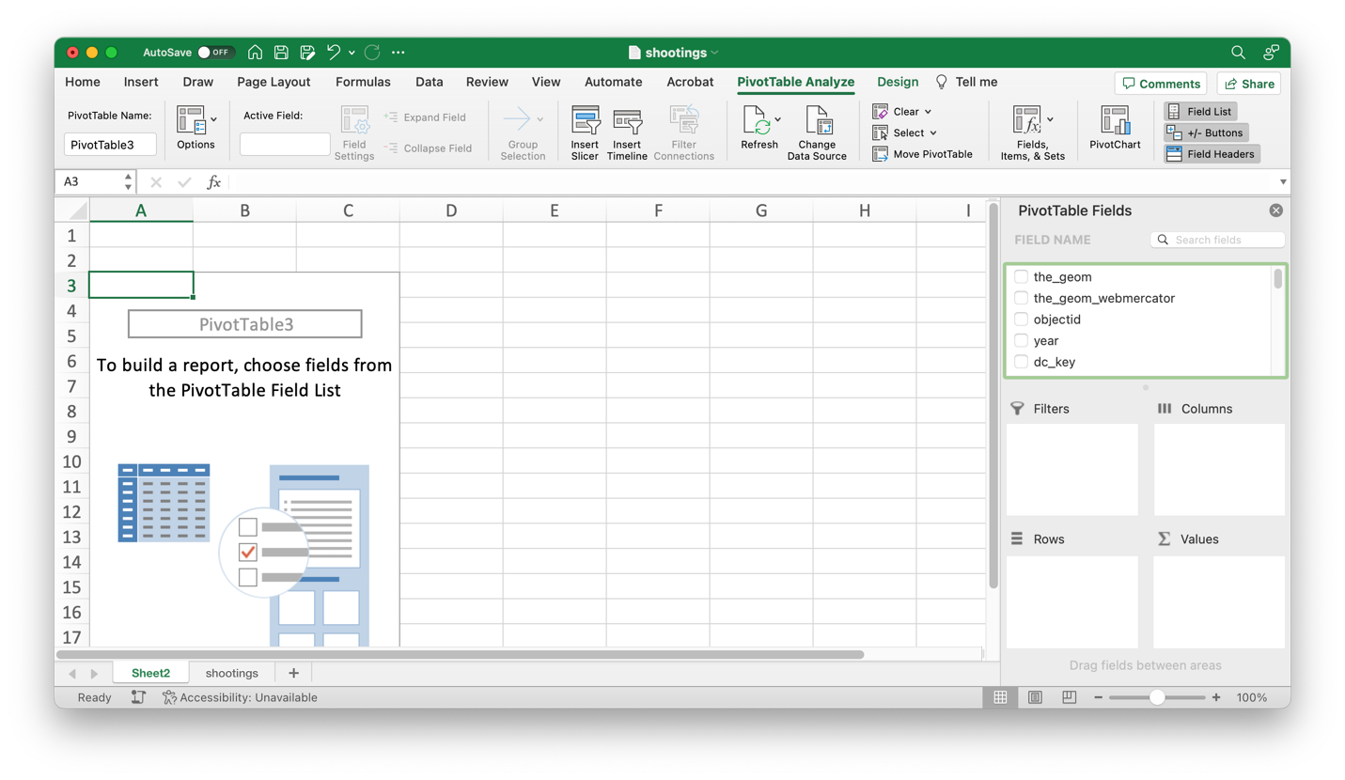

1. Click and drag the **year** and **fatal** variables to the Filters box

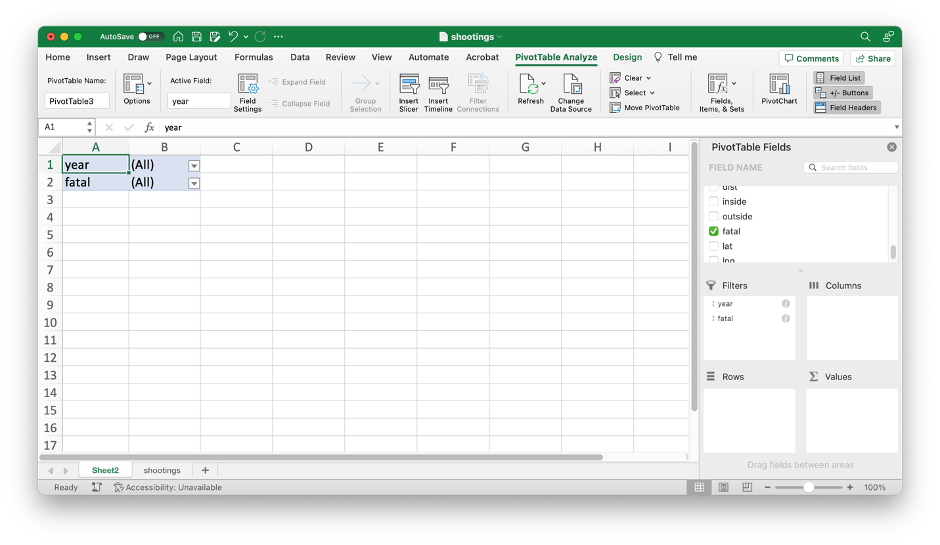

1. Click and drag the **race** and **latino** variables to the Rows box

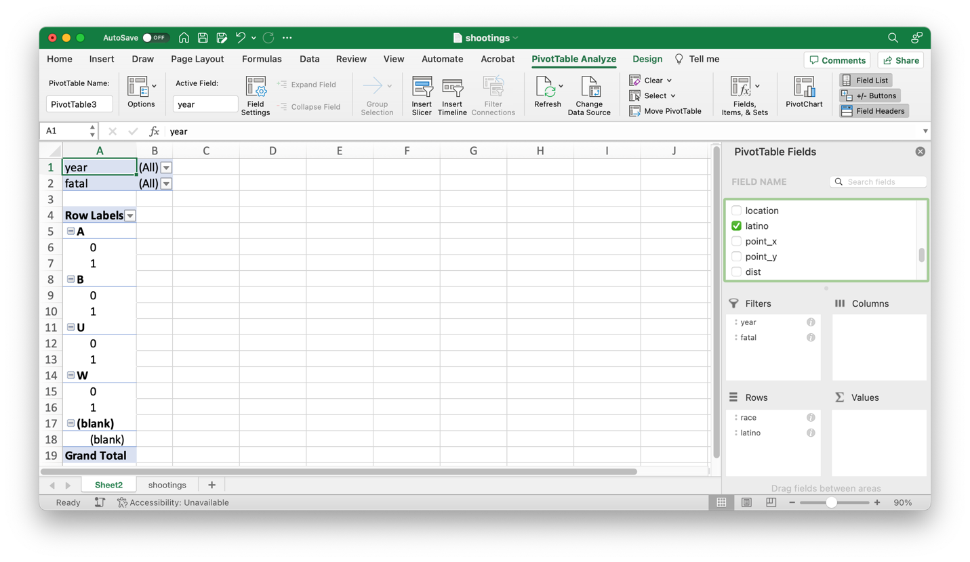

1. Click on the table labels to edit them. Consider customizing them so that they are more descriptive (e.g., A = Asian, 0 = Non-Hispanic)

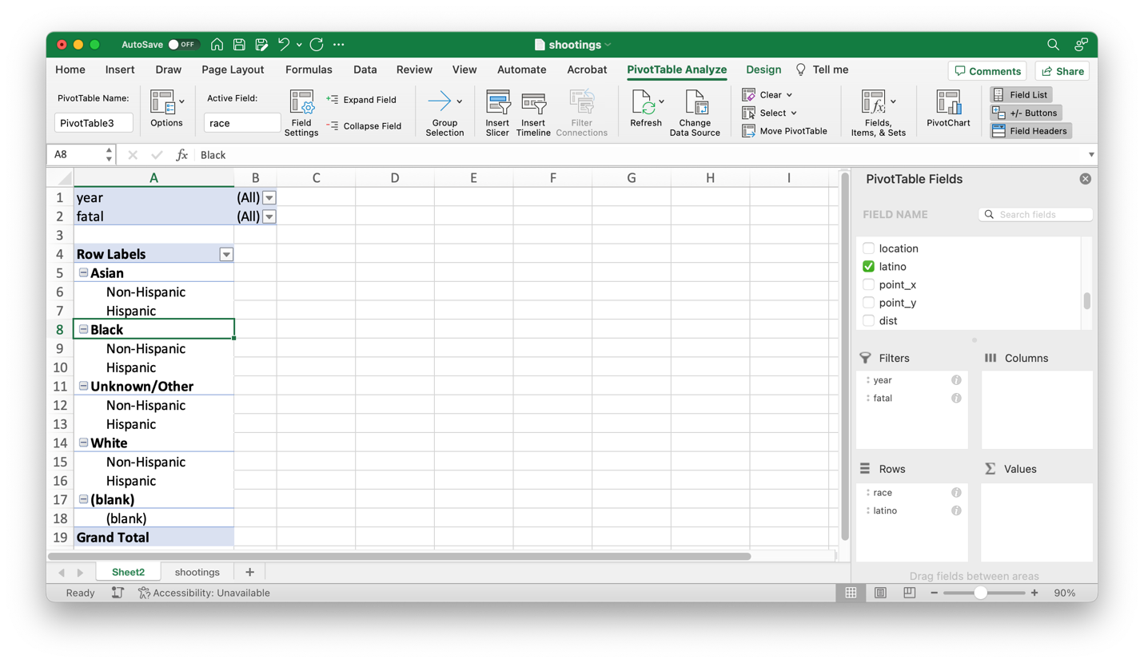

1. Click and drag the **sex** variable to the Columns box

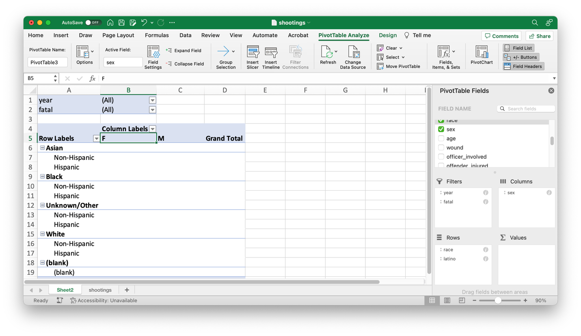

1. Customize table labels for the **sex** variable

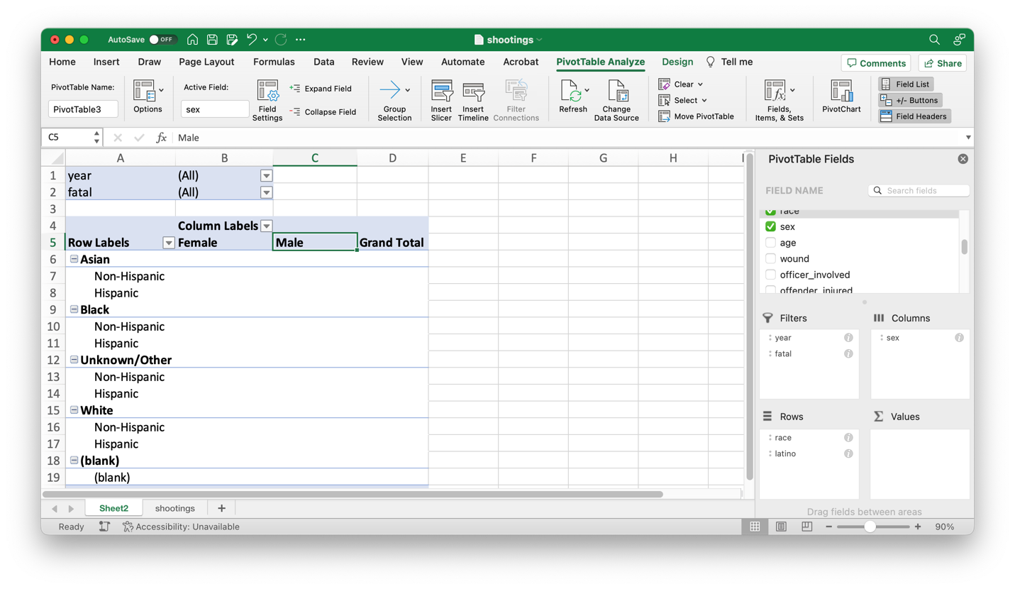

1. Add **race** variable to the Values box. This will automatically count the number of shooting victims by **race** (it shows up as “Count of race”)

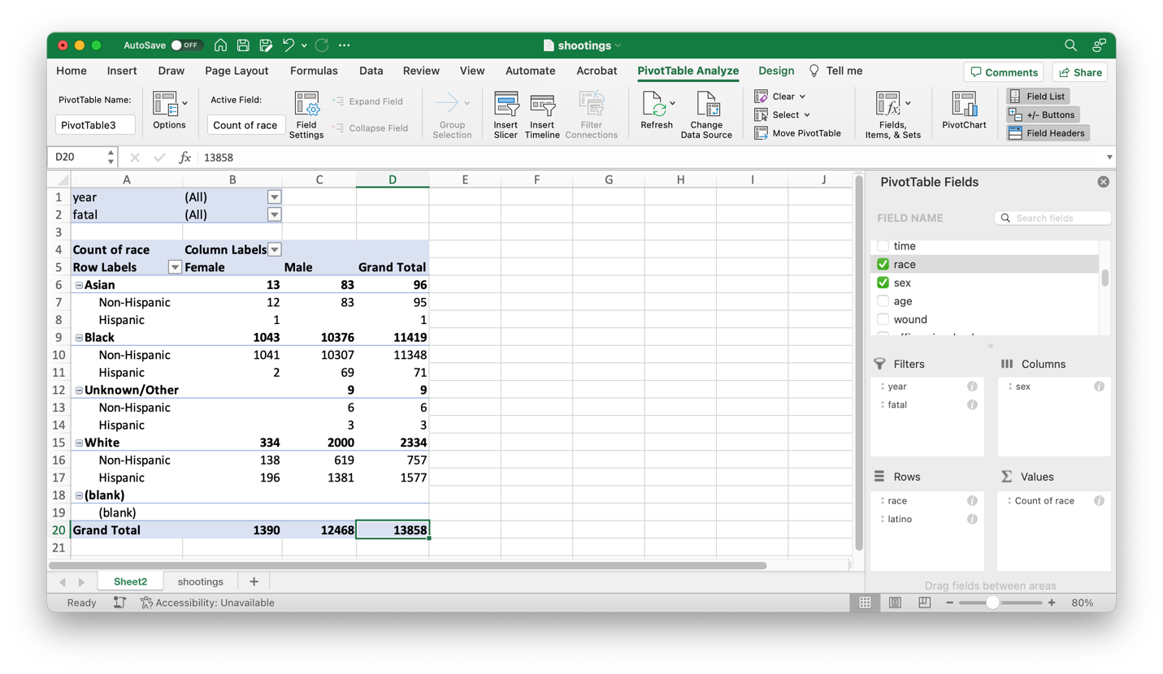

# Visualizing data

1. Insert a PivotChart using the PivotTable Analyze menu that is available when the PivotTable is selected

Steps: PivotTable Analyze > PivotChart

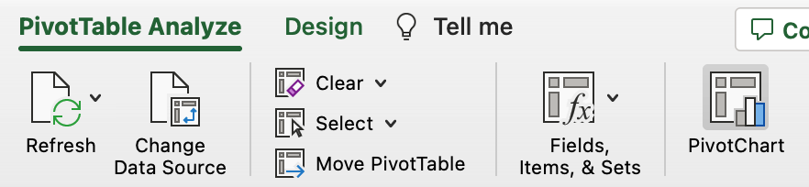

1. This will automatically create a bar chart using the information in your PivotTable

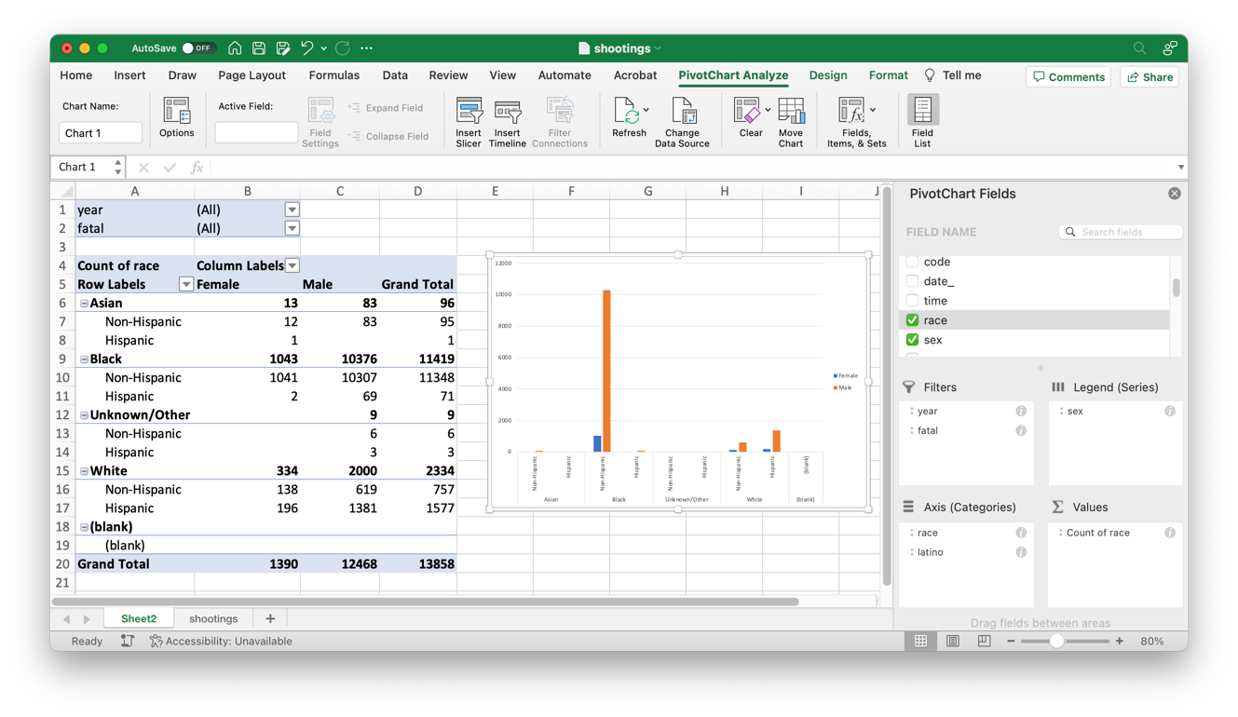

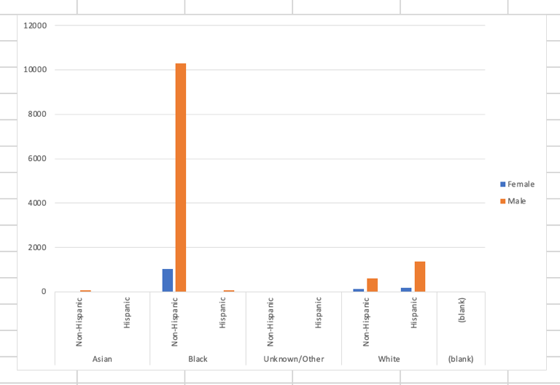

1. Consider changing the PivotChart so that the bars are horizontal. These charts can often be easier to read than vertical bars

Steps: Right click on the PivotChart > Change chart type > Column > 2-D Bar

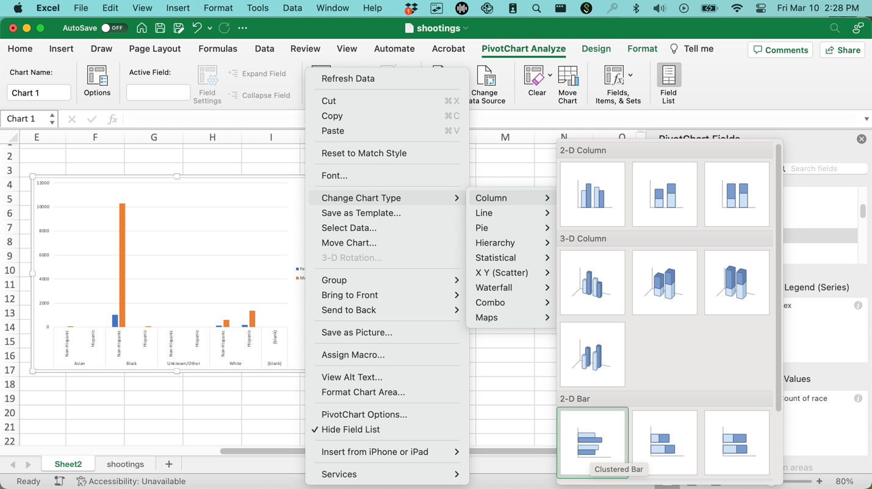

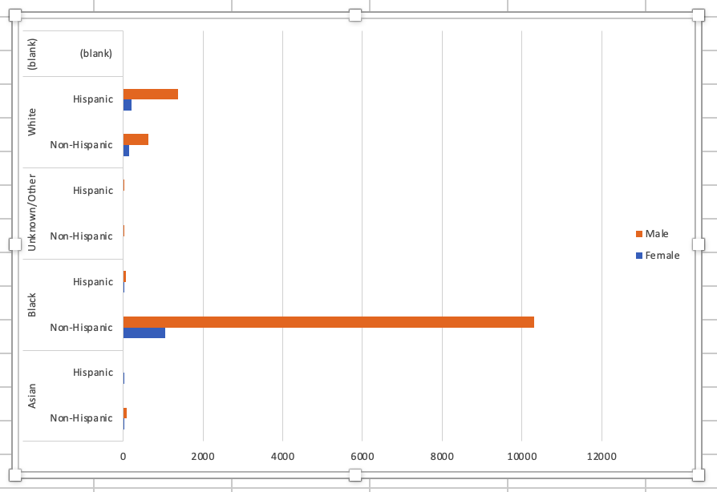

1. Use the **year** filter you added to your PivotTable to filter the data to 2023

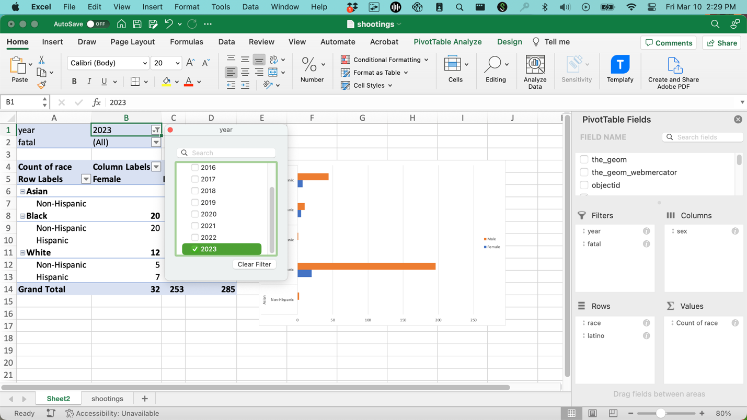

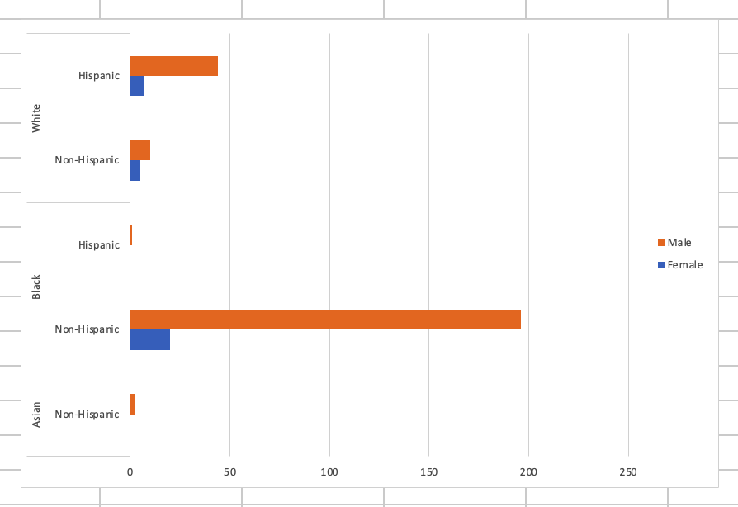

1. Consider adding data labels so that the counts of shooting victims are reflected in the PivotChart in addition to the PivotTable.

Use the Design menu that is available when the PivotChart is selected

Steps: Design > Add Chart Element > Data Labels > Outside End

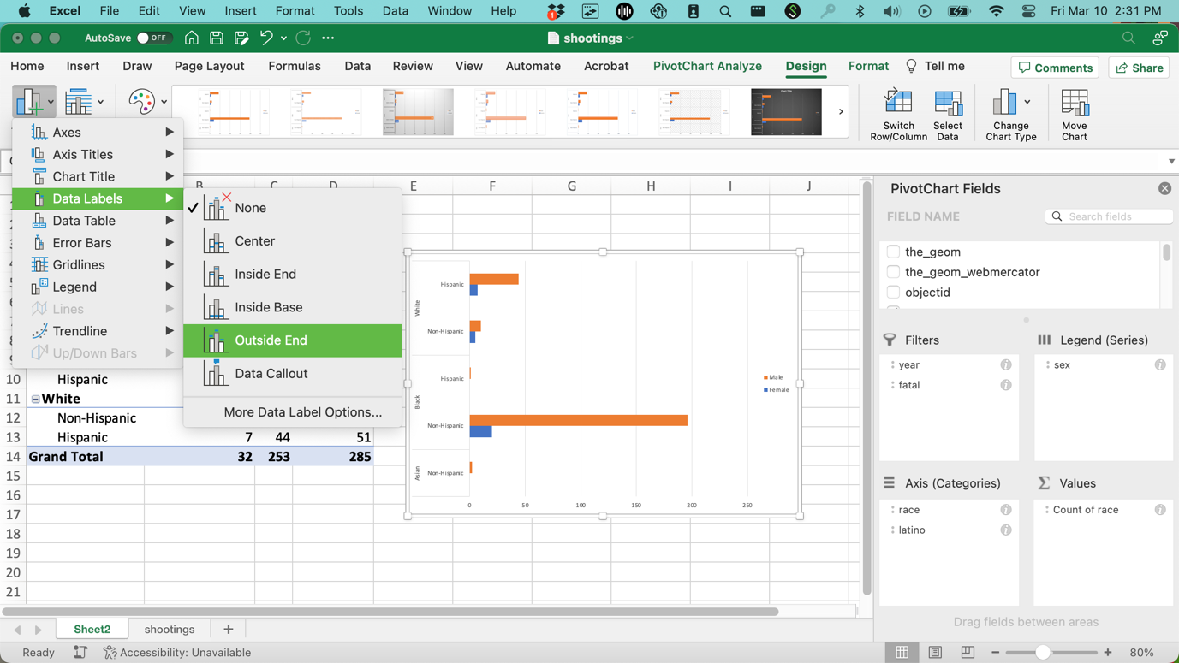

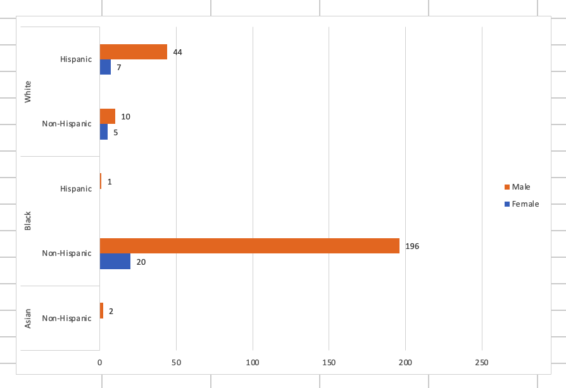

1. The summary in the PivotTable and the data shown in the PivotChart are currently showing counts grouped by the **race**, **latino**, and **sex** variables. You might consider playing around with the variables to summarize and visualize the data in a different way.

For example, if you want your bar chart to group shooting victims of all **sex** categories together, you can click and drag the **sex** variable out of the Columns box of the PivotTable panel.

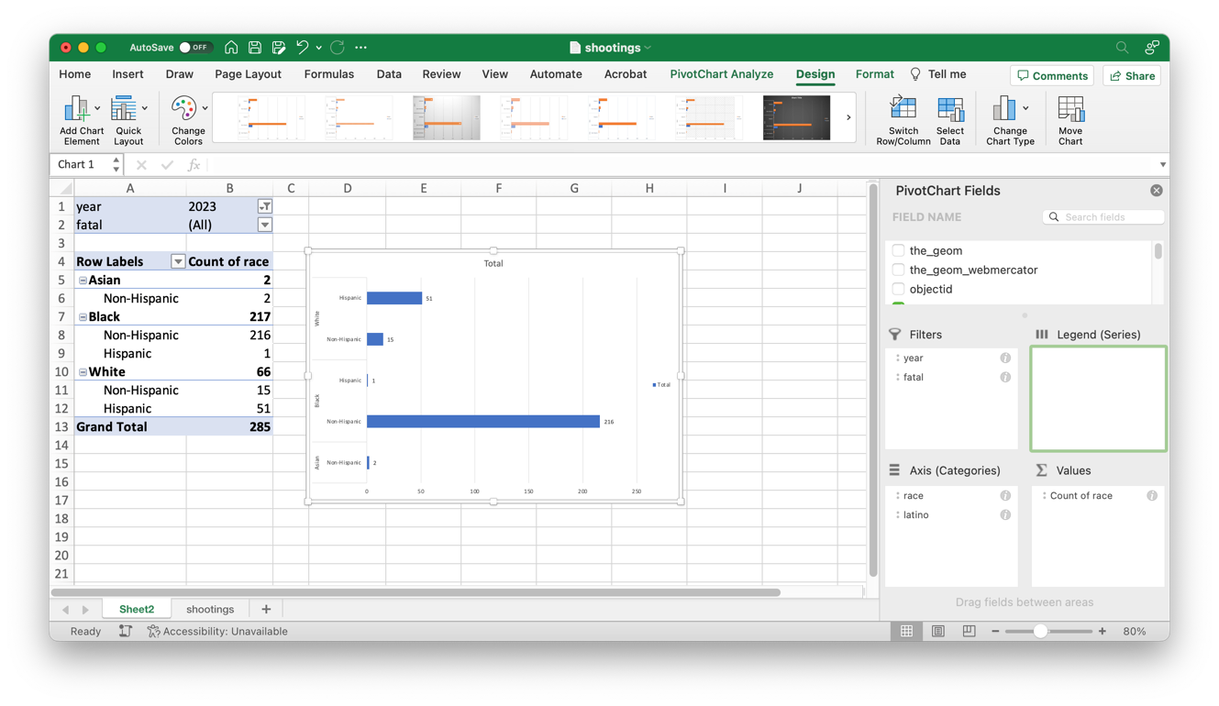

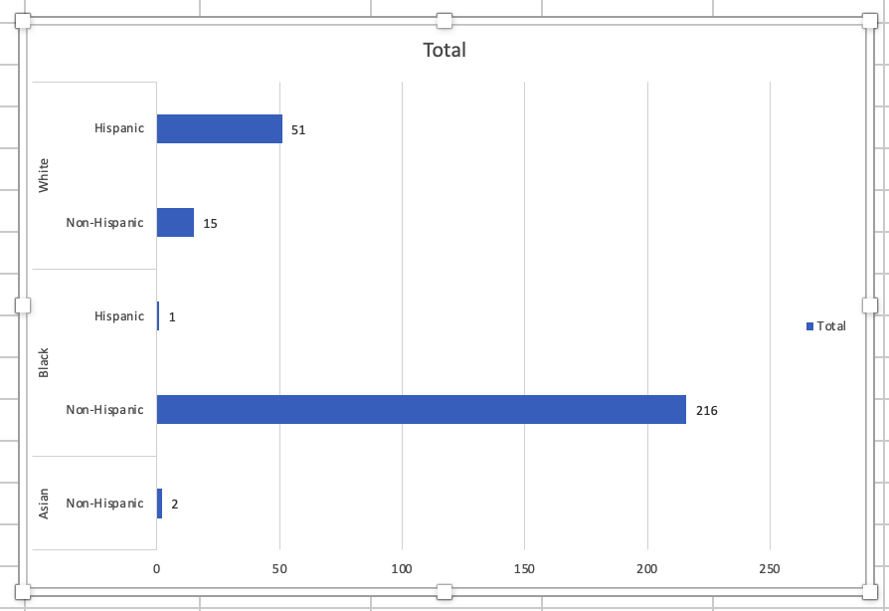

1. Lastly, there are many ways to further customize the chart. You might consider giving it a more descriptive title that reflects the story that the data are telling, and making the text larger so that it is more readable.

You can learn more about how to customize Excel charts in the following resources:

* [Video: Customize charts - Microsoft Support](https://support.microsoft.com/en-us/office/video-customize-charts-15032b6b-0ec5-422c-8550-dbc5b0217bdf)
* [Change the color or style of a chart in Office - Microsoft Support](https://support.microsoft.com/en-us/office/change-the-color-or-style-of-a-chart-in-office-f4db3f23-f5a1-4b30-abb3-62e8c2c33d9b)